**Mr. Montante**

**7th grade Social Studies Packet**

**Questions can be answered via email:** [**mmontante@nfschools.net**](mailto:mmontante@nfschools.net)

**Also you can join my Remind at the following website:** <https://www.remind.com/join/montante2>

**If technology is available at a later date you can do the same assignment online. I have detailed instructions on my webpage on the Gaskill website.**

**To complete this packet answer all questions in complete sentences. Please note any special directions on pages inside the packet.**

**Student Objectives:**

* **Students can explain Checks and Balances among the 3 branches.**
* **Students can explain the shared and reserved powers of national and state governments.**
* **Students can explain how a bill becomes a law and how checks may prevent bills from becoming laws.**
* **Students can explain the process of amending the constitution.**
* **Students can compare and explain similarities between the U.S. Constitution and New York State’s.**

**Directions:** Answer all questions in complete sentences. Use the R.A.C.E strategy to help you.

**US Government**

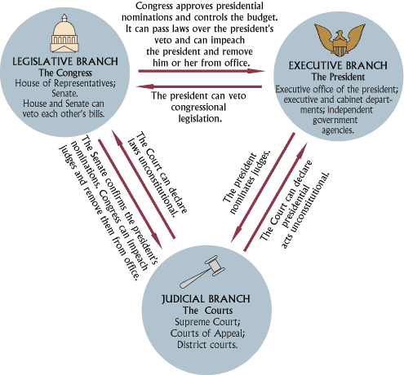

1. How many branches of the US government are there?
2. Why might the people who wrote the constitution wanted to split up duties and powers of the government into separate branches?
3. Each branch can put a check on each other to stop them from becoming too powerful.
4. Select one example from the chart that stops the President from becoming too powerful:
5. Select one example from the chart that stops the Congress from becoming too powerful:
6. Select one example from the chart that stops the Courts from becoming too powerful:

**GO TO THE NEXT PAGE**

**Checks and Balances**

The Constitution created three separate branches of the government: the Legislative Branch (Congress), the Executive Branch (President), and the Judicial Branch (Supreme Court). In order to make sure that one branch didn't become too powerful, the Constitution has "checks and balances" that enable each branch to keep the others in line.  
  
**Separation of Powers**  
  
The powers of the government are "balanced" between the three branches. Each branch has different powers. For example, the Congress makes laws, sets the budget, and declares war. The President appoints judges, is Commander in Chief of the military, and can grant pardons. Finally, the Supreme Court interprets the law and can declare a law unconstitutional.  
  
**Checks on each of the Branches**  
  
Each branch has "checks" on it from the other branches that are meant to keep the branch from becoming too powerful.

  
**The Congress**  
  
The president can check the Congress by vetoing a bill. When the president veto's a bill it has to go back to Congress and must be passed by a two-thirds majority in order to become a law. The Executive Branch also has some presence in the Senate as the vice-president is considered president of the Senate. The vice-president becomes the deciding vote in the case of a tie in the Senate.

The Supreme Court can check the Congress by declaring a law unconstitutional. This check isn't actually part of the Constitution, but is considered a part of the law since the landmark ruling of *Marbury V. Madison* in 1803.

1. What was one way the President can check congress?
2. How does the Supreme Court check the Congress?

  
  
**The President**  
  
The Congress can check the power of the president a number of ways. The first way is through impeachment where the Congress votes to have the president removed from office. The next way is through "advice and consent." While the president can appoint judges and other officials, the Congress must approve of them.  
  
The Supreme Court can check the president by declaring executive orders as unconstitutional.

1. What is one way that Congress can check the President’s power?
2. How does the Supreme Court check the President?

  
**The Courts**  
  
The Congress can check the power of the courts through impeachment. It can vote to remove judges from office. Many more judges have been impeached than presidents.  
  
The president checks the power of the courts by appointing new judges. The power of the Supreme Court can swing greatly on a single appointment. The Congress has a part in this check as well because they must approve the president's appointment.

1. How does Congress check the power of the courts?
2. How does the President check the power of the courts?

**GO TO THE NEXT PAGE**

**Federalism**

**Tenth Amendment**

The Tenth Amendment was part of the Bill of Rights that was added to the Constitution on December 15, 1791. This amendment states that any power not specifically given to the federal government by the Constitution belongs to the States and the people.  
  
**From the Constitution**  
"The powers not delegated to the United States by the Constitution, nor prohibited by it to the States, are reserved to the States respectively, or to the people."  
  
**The Federal Government**  
The federal government is another name for the national government (Congress, the President, and the Supreme Court) of the United States. It is defined by the U.S. Constitution.  
  
**Federal and State Governments**  
The United States was formed as a group of states under one federal government. The federal government has the powers given to it by the Constitution, while the state governments and the people have the rest of the powers.  
  
The Tenth Amendment was added to insure that the powers of the federal government remain limited. The writers of the Tenth Amendment wanted to make it clear that the power of the federal government comes from the states and the people, not the other way around.

The 10th Amendment created **Federalism** which is a system that has multiple levels of government (National, State, Local [County & Town]) working together. Certain levels of government had certain jobs and powers.

**Which is higher, state law or federal law?**  
This can be a tricky question. The highest power in the land is the Constitution. This makes federal law the higher power. However, federal law is limited in its powers to only what is specifically stated in the Constitution. The states and the people have all other powers.

**Powers of the Federal Government**  
Some examples of powers of the federal government include:

* Raising and maintaining the armed forces
* Declaring war
* Collecting taxes
* Regulating commerce between the states
* Coining and regulating money
* Setting standards of weights and measures
* Establishing a national bank
* Implied powers that are considered "necessary and proper" to carry out the laws in the Constitution.

**Powers of the State Governments**  
Some examples of state powers include:

* Traffic laws
* Collecting local taxes
* Issuing licenses such as driver's licenses and marriage licenses
* Holding elections
* Regulating commerce within the state
* Building and maintaining roads and schools
* Police and fire departments
* Local business laws
* Regulating property use, ownership, and sales

**SEE CHARTS AND QUESTIONS ON NEXT PAGE**

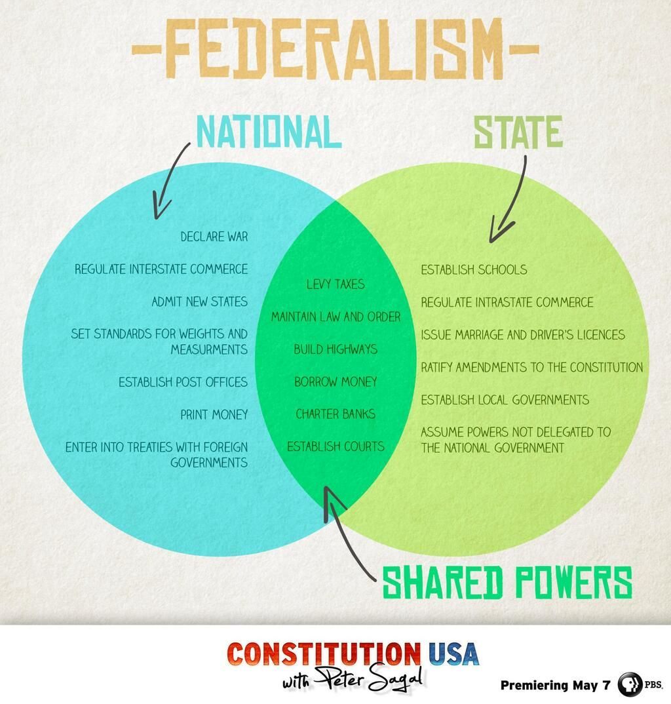

* 1. Define Federalism in your own words:
  2. Which amendment created Federalism?

**GO TO NEXT PAGE**

* 1. Give examples of the following
     1. 3 Federal (national) Powers:
     2. 3 State Powers:
     3. 3 Shared Powers:

**END OF WORK FOR APRIL 27th to May 1st. GO ON TO NEXT WEEK.**

**Directions:** Answer each question in complete sentences. Use the R.A.C.E strategy to complete your answers.

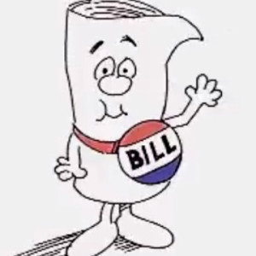**HOW LAWS ARE MADE**

**How a Bill Becomes a Law**

Creating laws is the U.S. House of Representatives’ most important job. All laws in the United States begin as bills. Before a bill can become a law, it must be approved by the U.S. House of Representatives, the U.S. Senate, and the President. Let’s follow a bill’s journey to become law.

**The Bill Begins**

Laws begin as ideas. These ideas may come from a Representative—or from a citizen like you. Citizens who have ideas for laws can contact their Representatives to discuss their ideas. If the Representatives agree, they research the ideas and write them into bills.

1. Where does the law come from?

**The Bill Is Proposed**

When a Representative has written a bill, the bill needs a sponsor. The Representative talks with other Representatives about the bill in hopes of getting their support for it. Once a bill has a sponsor and the support of some of the Representatives, it is ready to be introduced.

**The Bill Is Introduced**

In the U.S. House of Representatives, a bill is introduced when it is placed in the hopper—a special box on the side of the clerk’s desk. Only Representatives can introduce bills in the U.S. House of Representatives.

When a bill is introduced in the U.S. House of Representatives, a bill clerk assigns it a number that begins with H.R. A reading clerk then reads the bill to all the Representatives, and the Speaker of the House sends the bill to one of the House standing committees.

**The Bill Goes to Committee**

When the bill reaches **committee**, the committee members—groups of Representatives who are experts on topics such as agriculture, education, or international relations—review, research, and revise the bill before voting on whether or not to send the bill back to the House floor.

If the committee members would like more information before deciding if the bill should be sent to the House floor, the bill is sent to a subcommittee. While in subcommittee, the bill is closely examined and expert opinions are gathered before it is sent back to the committee for approval.

1. What is a committee?
2. What does the committee do?

**The Bill Is Reported**

When the committee has approved a bill, it is sent—or reported—to the House floor. Once reported, a bill is ready to be debated by the U.S. House of Representatives.

**The Bill Is Debated**

When a bill is debated, Representatives discuss the bill and explain why they agree or disagree with it. Then, a reading clerk reads the bill section by section and the Representatives recommend changes. When all changes have been made, the bill is ready to be voted on.

1. Opinion: Why might bills (future laws) be debated?

**The Bill Is Voted On**

There are three methods for voting on a bill in the U.S. House of Representatives:

1. Viva Voce (voice vote): The Speaker of the House asks the Representatives who support the bill to say “aye” and those that oppose it say “no.”
2. Division: The Speaker of the House asks those Representatives who support the bill to stand up and be counted, and then those who oppose the bill to stand up and be counted.
3. Recorded: Representatives record their vote using the electronic voting system. Representatives can vote yes, no, or present (if they don’t want to vote on the bill).

If a majority of the Representatives say or select yes, the bill passes in the U.S. House of Representatives. The bill is then certified by the Clerk of the House and delivered to the U.S. Senate.

**The Bill Is Referred to the Senate**

When a bill reaches the U.S. Senate, it goes through many of the same steps it went through in the U.S. House of Representatives. The bill is discussed in a Senate committee and then reported to the Senate floor to be voted on.

Senators vote by voice. Those who support the bill say “yea,” and those who oppose it say “nay.” If a majority of the Senators say “yea,” the bill passes in the U.S. Senate and is ready to go to the President.

1. After a bill passes the house it goes to the Senate. What happens to the bill in the Senate?

**The Bill Is Sent to the President**

When a bill reaches the President, he has three choices. He can:

1. Sign and pass the bill—the bill becomes a law.
2. Refuse to sign, or veto, the bill—the bill is sent back to the U.S. House of Representatives, along with the President’s reasons for the veto. If the U.S. House of Representatives and the U.S. Senate still believe the bill should become a law, they can hold another vote on the bill. If two-thirds of the Representatives and Senators support the bill, the President’s veto is overridden and the bill becomes a law.
3. Do nothing (pocket veto)—if Congress is in session, the bill automatically becomes law after 10 days. If Congress is not in session, the bill does not become a law.
4. How does a bill finally become law?
5. How can the bill be stopped from becoming law?

**The Bill Is a Law**

If a bill has passed in both the U.S. House of Representatives and the U.S. Senate and has been approved by the President, or if a presidential veto has been overridden, the bill becomes a law and is enforced by the government.

**Amendments**

Amendments are rules added to the constitution to cover things not covered in the original articles we read or a way to protect rights for citizens no matter what other laws are added. The first 10 amendments we already went over, things like right to free speech, right to bear arms, and several amendments dealing with protect the rights of those accused of crimes. The last of the first 10 amendments even protect state and local governments and gives them the responsible for basically everything (schools, roads, parks, hospitals, etc.)

The Bill of Rights (the first 10 amendments) were added to the Constitution as a way to get support from delegates at that convention that fear the Constitution may create a very powerful national government that could violate rights. However, the US constitution has more than just 10 amendments. It currently has 27 amendments. Some were added for rules, (the 18th amendment basically outlawed alcohol, and the 27th amendment made a rule about Congress salary changes) and other amendments protected and gave new rights (13th amendment freed slaves and outlawed it, the 19th Amendment gave women the right to vote.)

The main question you may have is, “how do we add new rules to the constitution?”

It takes two steps to add an amendment to the Constitution:

Step 1: Proposal –

1. An amendment can be proposed by either a two-thirds vote in Congress, including both the House of Representatives and the Senate.
2. An amendment can be proposed at a national convention made up of two-thirds of the states.

All our current amendments were through option A, proposed by Congress.

1. What are the two ways you propose amendments to the Constitution?

Step 2: Ratification - Next, the amendment has to be **ratified,** or approved. It can be ratified by either three-fourths of the state legislatures or by state conventions in three-fourths of the states.

1. How is an amendment approved?
2. Why do we, as a country need to add amendments to the constitution?
3. If you could propose an amendment what would it be?

**New York State Constitution Information**

As per the 10th Amendment, every state in the United States has the rights and responsibility to make their own state government to take care of things not covered in the constitution. Many states, New York included, made state constitutions that were similar to the Nation constitution but did make some changes. Even though certain names of positions are different their roles are the same.

|  |  |  |
| --- | --- | --- |
|  | National | New York State |
| Executive | President | Governor |
| Upper Legislative House | Senate | State Senate |
| Lower Legislative House | House of Representatives | State Assembly |
| Judicial | Supreme Court | State Supreme Court |

**What is the Assembly?**

The New York State Legislature, which is older than the U.S. Congress, was established as a law-making body in 1777. The Legislature is comprised of two houses, the Assembly and the Senate, both of which have co-equal powers. These two houses have the power to make all laws in all areas of the state except those that have been reserved to the federal government or to the people.

1. What are the two houses in the New York State Legislature called?

The first Assembly, under the Constitution, was composed of seventy members from the existing fourteen counties of the State. Only possessing twenty pounds, tenants paying an annual rental of at least forty shillings and taxpayers were eligible to be Assembly members. An increase of one member could be added to the membership whenever the census (every ten years) showed an increase of one-seventieth in the population, until the total membership had reached 300. By 1801, the number of members had increased to 108, but the law was found to be unequal. Consequently, a Constitutional amendment was adopted that year reducing the membership to 100 and fixing as the maximum to which it could be increased. This increase was to be allowed, after each census, at the rate of two new members annually. In 1808, twelve new members were added and in 1815 there was a further increase of fourteen. The Constitution of 1821 fixed and limited the membership of the Assembly at 128. This number remained in effect until 1894 when the Constitution of that year increased the membership to 150.

1. The US house of representatives membership is based on population. How does the Assembly determine how many members there will be?
2. How many members are there in the Assembly as of 1894?

Since 1938, Assembly members have been elected in even years for two year terms. Vacancies are filled by special election. The Assembly meets annually in unlimited session and convenes in the Capitol in Albany, in the Assembly Chamber.

1. Since 1938, how long is an Assembly members’ term?

In the Assembly, the presiding officer is the speaker, elected by the members, upon the nomination of the majority party. The speaker in the Assembly, directing the course of business, rules on procedure, and certifies the passage of bills. The speaker may leave the chair to debate on any measure, although it is rarely done, and may vote but is not required to do so except to break a tie. The speaker makes all committee assignments and appoints and directs the work of most of the Assembly staff.

1. What does the Speaker of the Assembly do?

The Constitution permits, with certain restrictions, legislative reapportionment by legislative enactment. Reapportionment is the act of re-defining the boundaries of legislative districts, according to the census. Acts reapportioning the Assembly districts were passed between 1879 and 1992. Reapportionment takes place every ten years based on population.

Under a reapportionment act passed at a special session in 1964, the Assembly had 165 members in 1966. In 1966, the courts set up a reapportionment plan that returned the Assembly to a membership of 150 to be elected in 1966 for two-year terms, a number and term that still exists today. To see which Assembly member represents your district, you'll need to know your zip code and can look online.

**STOP! SUBMIT BY 5:00 PM FRIDAY MAY 8th.**